**SQL FUNDAMENTALS**

**DISTINCT Clause**

**Introduction**

In this lesson, you will focus on the SELECT DISTINCT statement in SQL. Columns in the tables may often contain some duplicate values, but you may only need the distinct values as a result. Here comes the SELECT statement with the DISTINCT clause.

**ⓘ Info:** We have learned what the statement and keyword are. Here is another term which we introduced to you in this lesson: Clause. We want to define each three terms to help you gain better understanding. We will use query SELECT first_name, last_name, gender FROM employees; as an example to explain the concepts.

* **Keyword:**These are the individual elements which are predefined. In the example these are SELECT and FROM seperately.
* **Clause:**It's a part of a SQL statement. In our example, these ere SELECT first name, last name, gender and FROM employees.
* **Statement:**Thecomplete query is a statement. A statement may consist of two or more clauses.

The SELECT DISTINCT is used to return only distinct (different/unique) values to eliminate duplicate rows in a result set. Here is the syntax of the DISTINCT clause:

SELECT DISTINCT column_name(s) FROM table_name;

Q: What are some common clauses used with SELECT query in SQL?  
A: WHERE clause, ORDER BY clause, GROUP BY clause and HAVING clause

- Interview Q&A

By using this query, you explain to SQL that you only want to see the unique/distinct data from the column/columns in the given table.

**No Duplicated Rows**

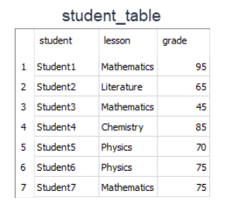

Assume that;

* You have a table named as *student_table* like above.
* You want to see only UNIQUE Values in student_column in the result set.
* Then, you should write a query like this.

query :

SELECT DISTINCT student FROM student_table;

After the execution of the query, you will get a result set like below.  
output :

student

----------

Student1

Student2

Student3

Student4

Student5

Student6

Student7

As you see in the result set, the query returned all the rows in the student column. Because all the rows in that column have unique values. So, in this example, we can see that if there are no duplicated rows in a column, SELECT and SELECT DISTINCTgives the same result.

**Duplicated Rows**

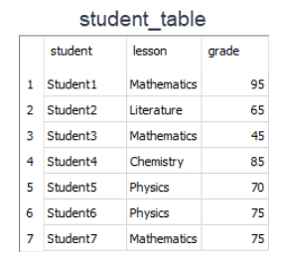

Let's write a different query to select unique lesson names from the lesson column. You should write a query like this.  
query :

SELECT DISTINCT lesson FROM student_table;

After the execution of the query, you will get a result set like below.  
output:

lesson

-----------

Mathematics

Literature

Chemistry

Physics

There are 7 rows in the student_table. But the result set has only 4 rows. Why?

* Lesson column consists of the following lessons; 3 Mathematics, 2 Physics, a Literature, and a Chemistry.
* So there are 3 duplicated rows of which 2 Mathematics and 1 Physics.
* DISTINCT clause eliminated 3 rows and so we get 4 unique rows.